Salesforce Day 5
Apex Development – Daily Task Documentation
Name: Golla Vaishnavi
Regd No: 23PA1A0572

Overview
This document summarizes today's Apex development work on the Placement Application module. The tasks span querying student and job records with SOQL, checking job eligibility, blocking duplicate applications, inserting a new application record through DML, updating application status as recruiters make decisions, and finally tying every step together into a single end-to-end business transaction. Each task below is described briefly and backed up with screenshots taken from the Salesforce Developer Console.

Task 1: Retrieve Student Information
Before processing the placement application, I pulled the student's details using a SOQL query. Rather than querying every field on the Student__c object, I limited the query to only what eligibility validation actually needs — name, branch, CGPA, and active backlog count. This reinforced why selective field retrieval matters: it keeps queries lighter and the overall application more performant.
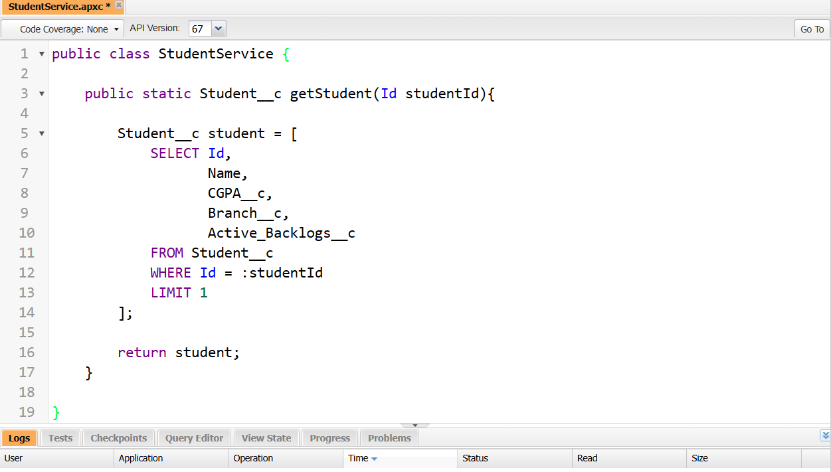
Figure 1.1 — StudentService.getStudent() Apex class retrieving selective fields from Student__c.
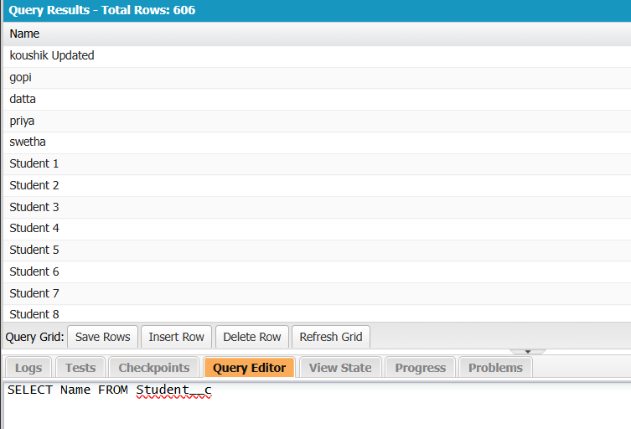
Figure 1.2 — Query Editor results confirming Student__c records (606 rows) queried successfully.

Task 2: Retrieve Job Eligibility Criteria
Next, I queried the selected job record to pull the company's eligibility criteria — minimum CGPA, eligible branch, maximum permitted backlogs, and the application deadline. These values are what the system checks against a student's profile to confirm they actually meet the company's placement requirements before an application is allowed to proceed.
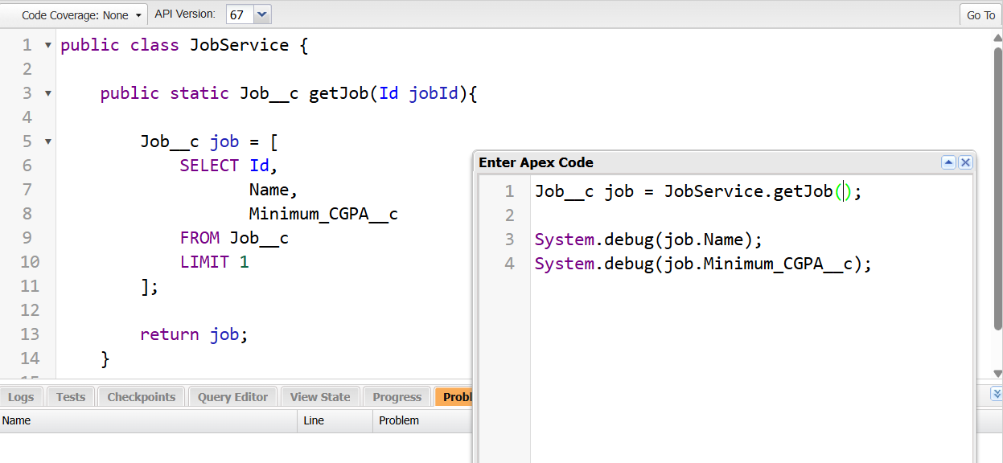
Figure 2.1 — JobService.getJob() Apex class and Execute Anonymous window used to test the method.
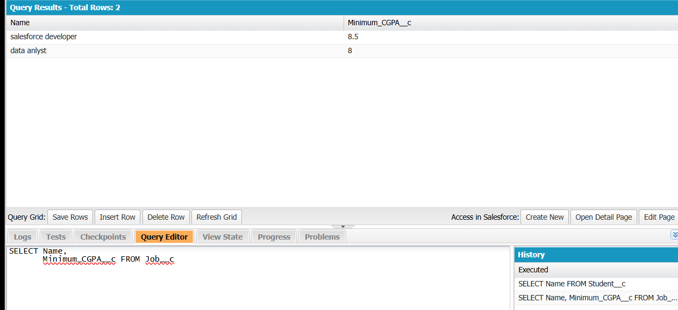
Figure 2.2 — Query results showing Job__c records with Name and Minimum_CGPA__c.

Task 3: Check for Duplicate Applications
This task added a check to stop students from applying twice to the same job. A SOQL query looks for an existing Application__c record for that student-job pair; if one already exists, the process halts and returns a message instead of inserting another record. This keeps the placement data clean and prevents duplicate entries from piling up.
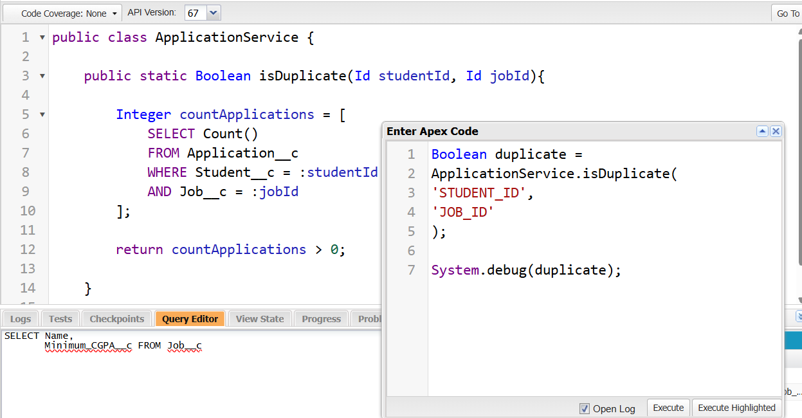
Figure 3.1 — ApplicationService.isDuplicate() Apex class checking for an existing Application__c record.

Task 4: Create and Save Application
Once all the validations passed, I used DML to insert a new application record — populating the student, job, status, and application date before saving it to Salesforce. This step reinforced a key principle: data should only be written after every validation rule has cleared, which is what keeps the placement process trustworthy.
Note: A screenshot of the DML insert step for this task was not captured during today's session.

Task 5: Update Application Status
Here, I fetched an existing application record and moved its status forward based on the recruiter's decision — depending on the stage, that meant Applied, Shortlisted, Interview Scheduled, Selected, or Rejected. After the DML update, I double-checked in Salesforce that the new status had actually been saved and reflected correctly.
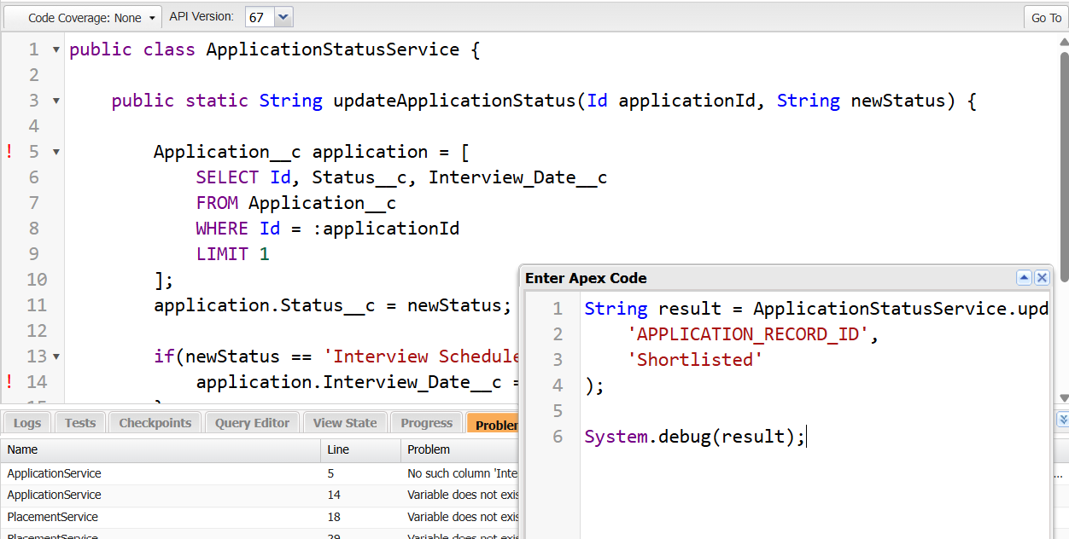
Figure 5.1 — ApplicationStatusService.updateApplicationStatus() Apex class and Execute Anonymous window used to test the method.

Task 6: Complete the Business Transaction
The final task pulled everything together into one complete placement application workflow. It starts by retrieving the student and job details, then checks for duplicate applications and validates eligibility. Once every business rule passes, a new application record gets created and saved, followed by a confirmation message letting the user know the submission went through. Building this out end-to-end made it clear how SOQL, DML, and Apex work together to form a single business transaction in Salesforce.
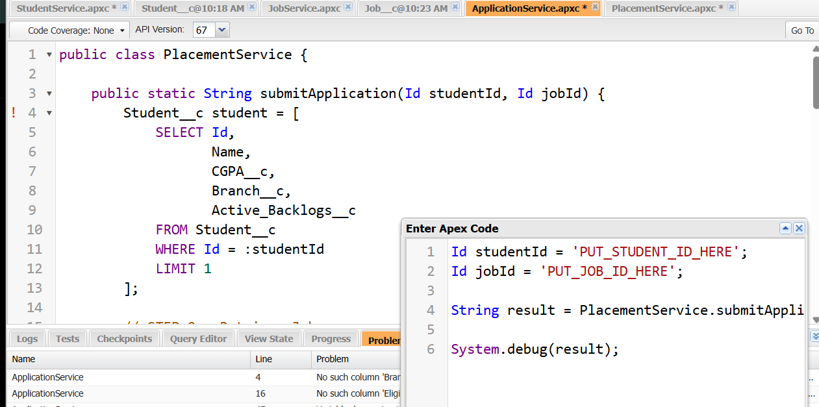
Figure 6.1 — PlacementService.submitApplication() Apex class bringing together eligibility checks, duplicate validation, and application creation.
Summary
Across these six tasks, the placement application flow came together end-to-end: selective retrieval of student and job data, duplicate-application checks, record creation through DML, status updates driven by recruiter decisions, and a single unified transaction wrapping all of it together. The net result is that only eligible, non-duplicate applications get saved and tracked, keeping the Placement Application module both efficient and dependable.

